Research Mapping on Historical Heritage in historical leraning: a Bibliometric Analysis From 2005-2025
Yuver Kusnoto¹*, Adi Wiranata¹
¹Universitas Muhammadiyah Metro, Indonesia
*Email: yuverkusnoto@ummetro.ac.id

Abstract
Research on historical heritage is crucial not only for the physical preservation of heritage assets but also for sustaining their cultural meanings and functional values for present and future generations. Educational institutions play a strategic role in transmitting these values by integrating historical heritage into history learning processes. This study aims to map the development and research trends of historical heritage in the context of history education through a bibliometric analysis. A systematic search of the Scopus database was conducted for publications published between 2005 and 2025, resulting in 223 eligible articles. Bibliometric visualization and network analysis were performed using VOSviewer to identify influential authors, institutions, countries, and thematic clusters. The results indicate that Spain leads the field in terms of publication output, citation impact, and international collaboration. Maria Feliu was identified as the most influential author, while Universidad de Murcia, Universitat de Barcelona, and Universidad de Extremadura emerged as the most prominent institutions. The thematic analysis revealed four major research clusters, with virtual reality and augmented reality emerging as dominant and rapidly growing themes. These findings highlight a significant shift toward technology-enhanced heritage-based learning and underscore the increasing relevance of immersive technologies in advancing meaningful and engaging history education.

Received: 7 xxxx 202x  Revision: 9 xxxx 202x  Accepted: 31 xxxx 202x | Keywords: Historical heritage; Historical learning; Bibliometric analysis
Citation: Andrian, D. (2022). The existence of suluk during the Achmad Government in Rokan Hulu district (2006-2016). SWARNADWIPA, 10(2), 1-15. http://dx.doi.org/10.24127/sd.xxxx



This work is licensed under a Creative Commons Attribution-ShareAlike 4.0 International License.

INTRODUCTION
Based on data indexed in the Scopus database over the past two decades, a total of 16,694 articles have been published on the theme of historical heritage. This finding shows that studies on historical heritage have a high level of academic attention and continue to develop across disciplines. However, when viewed further from the perspective of the interests of the world of education, especially formal education, the contribution of historical heritage studies is still limited. In fact, education at every level has a strategic position as a medium for transmitting the values, meanings, and uses of cultural heritage objects and sites for the formation of historical awareness among students.
In this context, heritage-based learning is increasingly seen as a relevant approach in bridging the relationship between history, culture, and pedagogical practices. This approach allows history and culture to be understood not only as a collection of facts or narratives of the past, but as a living, contextual, and reflective learning experience. Through the integration of cultural heritage in the learning process, students are encouraged to develop a deeper understanding of cultural identity while fostering an appreciative attitude and responsibility for the preservation of cultural values amid increasingly complex social dynamics (Marques, 2025).
To systematically examine the direction, trends, and focus of historical heritage research related to educational interests, a methodological approach is needed that can comprehensively map the research landscape. Bibliometric analysis is one relevant approach because it combines quantitative and qualitative techniques in processing scientific publication data. This approach not only helps identify publication patterns, collaborations, and dominant themes, but also provides a clear visualization of the development and current status of a field of study (Agarwal et al., 2016; Zhang et al., 2023). Therefore, this study aims to examine research trends in historical heritage in relation to educational interests, with a particular emphasis on the field of history education.
A number of recent studies show a shift in trends in the use of historical heritage as a source and medium of learning. Studies conducted by Anwar et al.,(2025) and Srdanović et al., (2025), for example, place historical objects at the center of learning integrated with contemporary digital technology. This approach not only enriches the representation of historical material, but also expands opportunities for active student engagement through more interactive and multisensory learning experiences.
Furthermore, this trend shows that immersive technology has great potential to improve the quality of learning experiences in cultural heritage environments. The use of this technology has been proven to strengthen students' emotional connection with historical objects, increase their motivation to learn, and encourage a deeper and more reflective understanding of history. This is crucial considering that the main challenge of contemporary history education lies in presenting the past in a way that remains relevant and meaningful to the younger generation.
More specifically, the results of a survey conducted by Vargas et al.,( 2020) show that in the context of learning as part of the education system, the use of immersive technology has a significant impact. Augmented reality (AR), virtual reality (VR), and mixed reality (MR) technologies, along with their various supporting components, have been proven to increase student motivation. Through immersive visualization and simulation, students can understand the way of life of their ancestors, learn about customs, building forms, and cultural practices of the past in a more concrete way. Thus, immersive technology plays a strategic role in strengthening the meaning of historical heritage as the foundation for contextual, critical, and experience-oriented history learning.
Considering the various trends revealed by these studies, it is necessary to conduct further mapping of the direction or trends of research relevant to historical and cultural heritage themes for educational purposes, so that such historical and cultural heritage can be put to better use, especially for the younger generation.
RESEARCH METHODS
This study began by identifying emerging research trends in the field of historical heritage in education. Research trends refer to scientific activities carried out by a group of researchers to examine specific topics or issues relevant to the needs of society, showing continuous development to date(Mazov et al., 2020). To facilitate the implementation of bibliometric analysis, this study adopted the stages or approaches proposed by Fosso Wamba & Mishra, (2017), as shown in the following section.
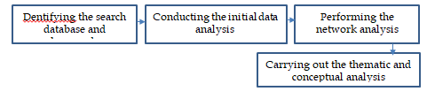

Figure 1. Bibliometric Analysis Stages (Fosso Wamba & Mishra, 2017)
- The first step in this research was to develop a study design by establishing the main topic of Historical Heritage. At this stage, the focus of the study was also limited to the field of Education. In addition, the temporal scope of the research was limited to publications that appeared in the last twenty years, namely from 2005 to 2025.
- The second stage of this research was data collection from the Scopus database. Scopus was chosen as the data source due to the completeness of its quantitative data and its high reputation and credibility. This database provides detailed information, ranging from searches for relevant and authoritative publications, identification of experts, to access to reliable data, metrics, and analytical tools (Scopus, 2025). To facilitate the search and data collection process, researchers used specific keywords in the Scopus database ( TITLE-ABS-KEY ( historical AND heritage ) AND TITLE-ABS-KEY ( "Historical Heritage" ) AND TITLE-ABS-KEY ( historical AND heritage AND in AND education ) ) AND PUBYEAR > 2004 AND PUBYEAR < 2026 AND ( LIMIT-TO ( LANGUAGE , "English" ) ) AND ( LIMIT-TO ( DOCTYPE , "ar" ) ). The limitations in the keywords include: Year range (2005-2025), Article language (English), and Document type is article. After filtering, a total of 223 articles were collected.
- 3. The data analysis and visualization stage was carried out using VOSviewer software. VOSviewer (Visualization of Similarities Viewer) version 1.6.19 is a metric analysis tool developed by Nees Jan van Eck and Ludo Waltman from the Center for Science and Technology Studies, Leiden University, Netherlands. This software is widely used in literature metrics studies due to its ability to present visualized knowledge maps based on analyzed data in accordance with the principles of literature analysis (VOSviewer, n.d.).
- 4. The final step is data interpretation. Researchers interpret all data displays from the analysis results in the form of a summary of research results, starting from keywords, year ranges and number of articles, networks, research trends, and author data with articles discussing Historical Heritage in School History Education.
RESULTS AND DISCUSSION
The results of the search can be seen in Figure 2. By following the search strategy and setting limitations, a total of 16,694 references from 2005 to 2025 were found. After the identification and duplication removal process, the number of publications included for visualization and final analysis was 223 articles.
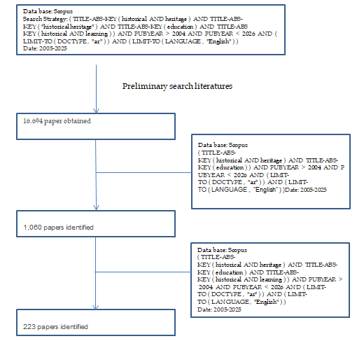
Figure 2. The Search Strategy and Setting Limitations
Annual Development Trends
The diagram shows figure 3 that the number of research publications on historical heritage in history education during the period 2005–2025 has increased significantly. In the early phase (2005–2008), the number of documents was still very low, ranging from 0–1 publication per year. Subsequently, in the period 2009–2013, there was a gradual increase, with the number of publications increasing from around 2 documents in 2009 to 5–6 documents in 2013.
Entering the 2014–2016 period, the trend declined again and fluctuated in the range of 2–3 documents per year, indicating that the theme of historical heritage had not yet fully stabilized as a focus of historical learning research. However, since 2017, the number of publications has increased sharply to around 12 documents, although it dropped to 10 documents in 2018.
During the 2019–2021 period, publications showed relatively high stability, ranging from 15 to 16 documents per year. The most significant increase occurred after 2022, when the number of publications jumped from around 15 documents to 25 documents in 2023, 36 documents in 2024, and peaked at around 49 documents in 2025.
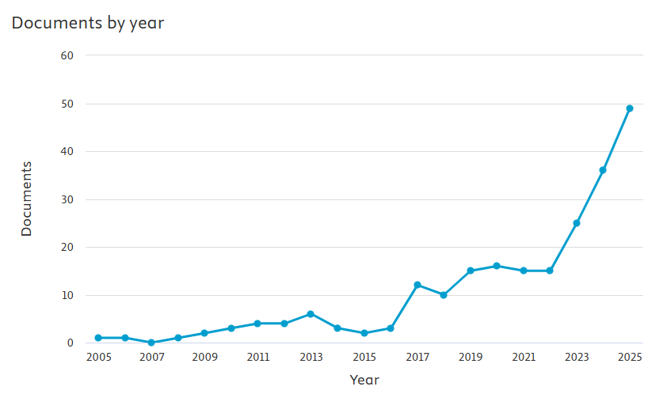

Figure 3. the number of research publications on historical heritage in history education during the period 2005–2025
Authors
Over the past 20 years, 16,694 authors have participated in writing about historical heritage, with various qualifications, ranging from the highest number of articles, the highest number of citations, affiliations, including the countries that have contributed the most research results related to the theme of historical heritage. After we limited the articles that wrote about historical heritage for the purposes of history learning, there were 223 articles that were filtered. Of these, there are several categories that have added value. For example, Feliu-Torruella, M has the most articles written about historical heritage related to history learning (González-Vázquez et al., 2021; Hernàndez-Cardona et al., 2022; Sospedra-Roca et al., 2022). Similarly, the theme most often referenced when other authors write about historical heritage related to learning is the article written by Mercán et al. entitled Virtual reality as a didactic tool for teaching history to early childhood teachers in training. These numerous references indicate that the trend regarding historical heritage is interesting when linked to the importance of history learning with a digital touch, such as virtual reality programs (Merchán et al., 2025).
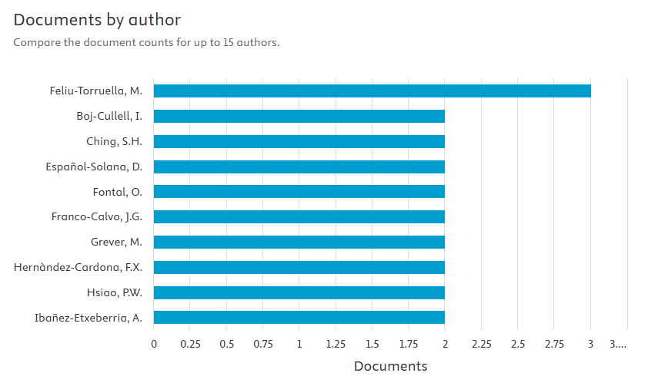

Figure 4. Top Ten Authors Based On Number Of Documents

Citation
The table 1 shows that the articles with the highest number of citations in the 2005–2025 period demonstrate a strategic position in shaping the direction of research in cultural heritage and history education. High citation rates are influenced not only by the age of the publication, but primarily by the conceptual strength, thematic relevance, and methodological contributions offered.
Some articles, such as Fleer,( 2021) and Grever et al.,( 2012), serve as primary references because they present a fundamental theoretical framework based on a cultural-historical approach and critical history education. These works broaden understanding of the relationship between past and present, imagination, identity, and historical distance, and thus serve as a conceptual foundation for further research.
Other articles, including Ijaz et al.,( 2017), Vargas et al., (2020), Luna et al.,(2019), Petrucco & Agostini,( 2016), Paulauskas et al., (2023), and Anwar et al., (2025), received high citations because they focused on the use of immersive technologies (AR, VR, MR, XR, and metaverse) in cultural heritage education. These articles not only showcase technological innovations but also present empirical evidence, implementation models, and easily replicable evaluative frameworks, making them important references for researchers and practitioners.
Meanwhile, studies by Gómez-Carrasco et al., (2020) and Savenije et al.,(2014) stand out for their central focus on educational actors and sensitive issues. By examining prospective teachers' perceptions and interpretations of sensitive heritage such as slavery, these articles enrich the discourse on historical literacy, identity, and the affective-moral dimension of history learning.

Table 1 Top Ten Autors With The Highest Number Of Citations
Rank | Refrances | Citations
1 | (Fleer, 2021) | 86
2 | (Ijaz et al., 2017) | 84
3 | (Vargas et al., 2020) | 74
4 | (Luna et al., 2019) | 45
5 | (Petrucco & Agostini, 2016) | 45
6 | (Grever et al., 2012) | 45
7 | (Gómez-Carrasco et al., 2020) | 42
8 | (Savenije et al., 2014) | 39
9 | (Anwar et al., 2025) | 38
10 | (Paulauskas et al., 2023) | 38

Based on the VOSviewer visualization image, it can be seen that the yellow dot representing Anwar et al., (2025), although a relatively recent publication, indicates that current research trends in historical heritage and education tend to adopt a digital technology approach. This indicates that this approach is currently one of the most sought-after research focuses in heritage-based education studies.
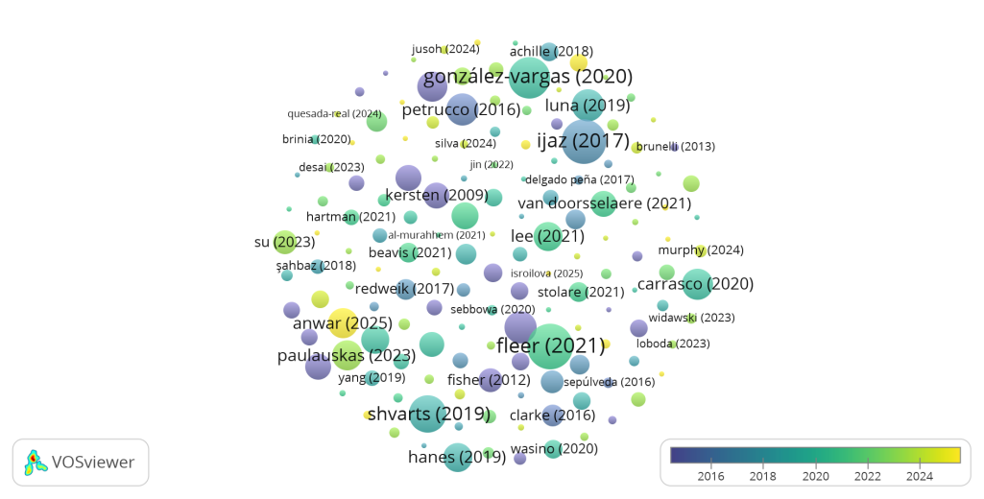
Another trend based on citations that is also the most popular is followed by Srdanović et al., (2025) who argue that the integration of gamification with immersive VR and AR technologies effectively increases user engagement, interest, and positive attitudes towards learning and preserving cultural heritage. The developed applications are able to provide interactive and immersive learning experiences, strengthen emotional engagement, and facilitate understanding, especially for the younger generation who are accustomed to the digital environment. Quantitative and qualitative findings indicate high user interest and readiness to utilize this technology, while also confirming that this approach has the potential for real and relevant implementation for the sustainability of cultural heritage preservation in the digital era.

Figure 5. Overlay Visualization Of Citations Based On Documents
Country
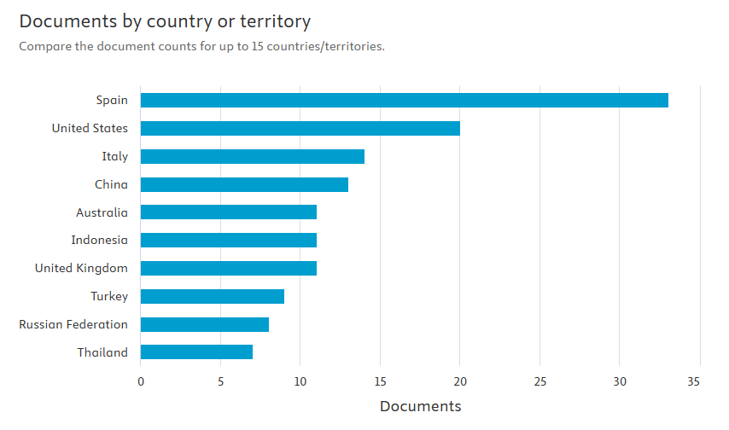
From 2005 to 2025, 62 countries contributed to research on historical heritage for educational purposes, particularly history education. As shown in the figure below, Spain contributed the most research on this topic, with 33 articles. The United States followed in second place with 20 articles, followed by Italy and China with 14 and 13 articles, respectively.

Figure 6. Top Ten Countries Based On Number Of Documents
The contribution of 62 countries to historical heritage-themed research for the benefit of history education during the period 2005–2025 demonstrates the global relevance of this issue. However, the dominance of Spain, the United States, Italy, and China reflects structural and contextual factors that drive research intensity in these countries. Spain and Italy possess a vast and diverse historical heritage, making historical heritage an integral part of national identity and a strategic learning resource within the education system. Support from cultural policies, the integration of historical heritage into the curriculum, and cross-institutional research collaborations have also strengthened research productivity in both countries.
Meanwhile, the high contributions of the United States and China are more influenced by their orientation toward educational innovation and the use of technology. The United States positions historical heritage as a medium for developing technology-based learning, digital literacy, and historical thinking skills, in line with its strong tradition of interdisciplinary education. On the other hand, China views historical heritage as a strategic instrument for strengthening national identity and cultural diplomacy, as well as part of a technology-based educational transformation. Overall, these findings confirm that the high level of attention to historical heritage themes in history education is influenced by a combination of rich cultural heritage, supportive educational policies, institutional research capacity, and readiness to adopt pedagogical and technological innovations.
Affiliation
The bar chart shows the distribution of the number of research papers on historical heritage in history learning based on institutional affiliation. The data shows that the highest contribution of publications comes from several universities in Europe, particularly Spain.
The Universidad de Murcia, the Universitat de Barcelona, ​​and the Universidad de Extremadura occupy the top positions, producing approximately four papers each. This finding indicates that these institutions demonstrate a strong commitment and consistency in developing historical heritage studies as an approach to history learning.
Intermediate contributions are demonstrated by the Universidad de Zaragoza, the Universidad de Valladolid, the Universidad del País Vasco, and the Sultan Idris University of Education, each producing approximately three papers. The presence of the Sultan Idris University of Education in this group indicates that historical heritage studies are not only developing in Europe but are also beginning to receive attention in Southeast Asia, particularly in the context of teacher education and history teaching.
Meanwhile, the Università degli Studi di Padova, the University of South Africa, and Université McGill show lower publication numbers, at around two documents per affiliate. While relatively small in number, these institutions represent a broader geographic spread of research and demonstrate that the theme of historical heritage has global appeal.
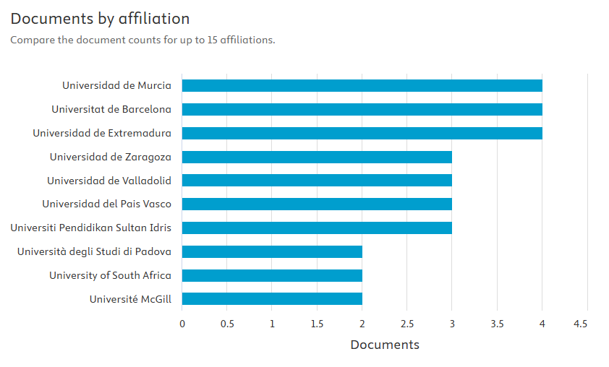

Figur 7. Top ten of research papers on historical heritage in history learning based on institutional affiliation
Keyword Co-occurrence and Thematic Clusters in Research Trends

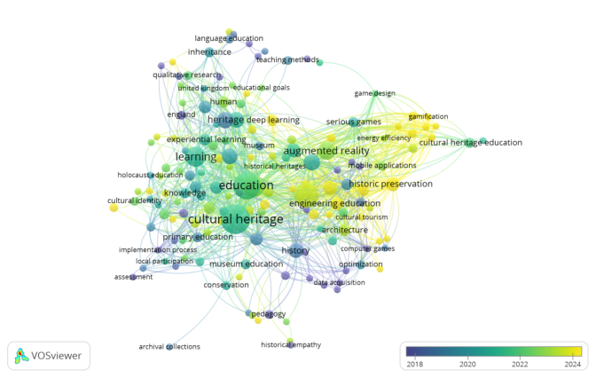

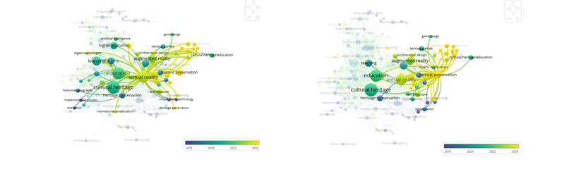

Figur 8. Overlay Visualization Of Keywords Based On The Years Of Historical Heritage In Historical Learning

With a minimum threshold of 10 documents, we conducted an analysis of the authors' collaboration network and identified a dense collaboration network among researchers, with the formation of several collaborative groups. Furthermore, an overlay map of the authors' collaboration network illustrates the authors' research period in the field of historical heritage for history learning, represented by the yellow color.
The dominance of yellow lines and dots in the visualization indicates that these themes represent the most cutting-edge research focuses and are experiencing significant growth. This trend can be understood as a response to the challenges of contemporary education, which is required to adapt to the characteristics of the digital generation. Integrating historical heritage into educational contexts through technological approaches, particularly application-based ones, is seen as an effective strategy to bridge the gap between static historical objects and the needs of dynamic, interactive, and contextual learning.
Furthermore, the development of digital technologies such as virtual reality-based applications, augmented reality Srdanović et al., (2025), and interactive platforms enables visual, immersive, and participatory representations of historical heritage. This approach not only increases accessibility to historical objects and sites but also enriches the learning experience by presenting more vivid and meaningful historical narratives. Therefore, the research trend linking historical heritage with technology-based education reflects a paradigm shift from history learning oriented toward knowledge transmission toward learning that emphasizes experience, emotional engagement, and strengthening students' historical awareness.
CONCLUSION
Based on the results of a bibliometric analysis of publications on the theme of historical heritage in the context of history education for the period 2005–2025, this study shows that academic attention to this issue continues to increase, although it remains concentrated in certain countries and institutions. Spain's dominance in the number of publications, citation impact, and collaborative networks confirms the strong integration between cultural policy, education, and heritage research. These findings also reveal a significant thematic shift toward the use of immersive technologies, particularly virtual reality and augmented reality, as the primary approach in heritage-based history learning. This shift marks a transformation of the history learning paradigm from a transmissive one to a more contextual, interactive, and meaningful learning experience. Overall, the results of this study emphasize the importance of strengthening historical heritage studies in history education through pedagogical and technological innovation, while also opening up opportunities for further research, particularly in countries that are still relatively underrepresented in the global research landscape.

REFERENCES
Agarwal, A., Durairajanayagam, D., Tatagari, S., Esteves, S. C., Harlev, A., Henkel, R., Roychoudhury, S., Homa, S., Puchalt, N. G., Ramasamy, R., Majzoub, A., Dao Ly, K., Tvrda, E., Assidi, M., Kesari, K., Sharma, R., Banihani, S., Ko, E., Abu-Elmagd, M., … Bashiri, A. (2016). Bibliometrics: Tracking research impact by selecting the appropriate metrics. Asian Journal of Andrology, 18(2), 296–309. https://doi.org/10.4103/1008-682X.171582
Anwar, M. S., Yang, J., Frnda, J., Choi, A., Baghaei, N., & Ali, M. (2025). Metaverse and XR for cultural heritage education: applications, standards, architecture, and technological insights for enhanced immersive experience. Virtual Reality, 29(2). https://doi.org/10.1007/s10055-025-01126-z
Fleer, M. (2021). Conceptual Playworlds: the role of imagination in play and learning. Early Years, 41(4). https://doi.org/https://doi.org/10.1080/09575146.2018.1549024
Fosso Wamba, S., & Mishra, D. (2017). Big data integration with business processes: a literature review. Business Process Management Journal, 23(3), 477–492. https://doi.org/10.1108/BPMJ-02-2017-0047
Gómez-Carrasco, C. J., Miralles-Martinez, P., Fontal, O., & Ibañez-Etxeberria, A. (2020). Cultural heritage and methodological approaches-an analysis through initial training of history teachers (Spain-England). Sustainability (Switzerland), 12(3), 1–21. https://doi.org/10.3390/su12030933
González-Vázquez, D., Feliu-Torruella, M., & Íñiguez-Gracia, D. (2021). The teaching of historical memory as a tool for achieving sdg 16 and teachers’ views on the exile memorial museum (Mume) routes. Sustainability (Switzerland), 13(24). https://doi.org/10.3390/su132413637
Grever, M., Bruijn, P. de, & Boxtel, C. van. (2012). Negotiating historical distance: Or, how to deal with the past as a foreign country in heritage education. Paedagogica Historica International Journal of the History of Education, 48(6). https://doi.org/https://doi.org/10.1080/00309230.2012.709527
Hernàndez-Cardona, F. X., Feliu-Torruella, M., Sospedra-Roca, R., & Boj-Cullell, I. (2022). Audiovisual narrative, re-enactment, and historical education: Hospitals in the Spanish Civil War. Frontiers in Education, 7(August), 1–11. https://doi.org/10.3389/feduc.2022.979175
Ijaz, K., Bogdanovych, A., & Trescak, T. (2017). Virtual worlds vs books and videos in history education. Interactive Learning Environments, 25(7). https://doi.org/https://doi.org/10.1080/10494820.2016.1225099
Luna, U., Rivero, P., & Vicent, N. (2019). applied sciences Augmented Reality in Heritage Apps : Current Trends in Europe. Applied Sciences, 9(13). https://doi.org/https://doi.org/10.3390/app9132756
Marques, G. M. (2025). Heritage Education , Sustainability and Community Resilience : The HISTOESE Project-Based Learning Model. 2008, 1–29.
Mazov, N. A., Gureev, V. N., & Glinskikh, V. N. (2020). The Methodological Basis of Defining Research Trends and Fronts. Scientific and Technical Information Processing, 47(4), 221–231. https://doi.org/10.3103/S0147688220040036
Merchán, M. J., Merchán, P., Pérez, E., Salamanca, S., & Corrales-Serrano, M. (2025). Virtual reality as a didactic tool for teaching history to early childhood teachers in training. Interactive Technology and Smart Education, 22(3). https://doi.org/https://doi.org/10.1108/ITSE-12-2024-0309
Paulauskas, L., Paulauskas, A., Blažauskas, T., Damaševičius, R., & Maskeliūnas, R. (2023). Reconstruction of Industrial and Historical Heritage for Cultural Enrichment Using Virtual and Augmented Reality. Technologies, 11(2). https://doi.org/10.3390/technologies11020036
Petrucco, C., & Agostini, D. (2016). TEACHING OUR CULTURAL HERITAGE USING MOBILE AUGMENTED REALITY. Journal Of-Learning and Knowledge Society, 12(3), 115–128.
Savenije, G. M., Van Boxtel, C., & Grever, M. (2014). Learning about sensitive history: “Heritage” of slavery as a resource. Theory and Research in Social Education, 42(4), 516–547. https://doi.org/10.1080/00933104.2014.966877
Scopus. (2025). Scopus Expertly curated abstract & citation database. https://www.elsevier.com/solutions/scopus?dgcid=RN_AGCM_Sourced_300005030
Sospedra-Roca, R., Hernàndez-Cardona, F. X., Feliu-Torruella, M., & Boj-Cullell, I. (2022). Social Museography and Sustainable Historical Heritage. Sustainability (Switzerland), 14(11). https://doi.org/10.3390/su14116665
Srdanović, P., Skala, T., & Maričević, M. (2025). InHeritage—A Gamified Mobile Application with AR and VR for Cultural Heritage Preservation in the Metaverse. Applied Sciences (Switzerland), 15(1). https://doi.org/10.3390/app15010257
Vargas, J. C. G., Jové, T., Fabregat, R., & Carrillo-Ramos, A. (2020). applied sciences Survey : Using Augmented Reality to Improve Learning Motivation in Cultural Heritage Studies. Applied Sciences, 10(3). https://doi.org/doi:10.3390/app10030897
VOSviewer. (n.d.). VOSviewer Visualizing Scientific landscapes. Retrieved February 18, 2023, from https://www.vosviewer.com/
Zhang, S., Lin, J., Feng, Z., Wu, Y., Zhao, Q., Liu, S., Ren, Y., & Li, H. (2023). Construction of cultural heritage evaluation system and personalized cultural tourism path decision model: An international historical and cultural city. Journal of Urban Management, 12(2), 96–111. https://doi.org/10.1016/j.jum.2022.10.001

