ANALYSIS OF THE EFFECT OF HOT FLUID FLOW SPEED VARIATIONS
ON POTATO CHIPS DRYING CAPACITY USING LPG GAS
Tungga Bhimadi Karyasa ¹, Syamsuri ^{2,*}

¹Jurusan Teknik Mesin, Universitas Gajayana Malang
²Jurusan Teknok Mesin, Institut Teknologi Adhi Tama Surabaya
*Corresponding author: syamsuri@itats.ac.id
Abstract
Some of the potato chips circulating in the community contain carbohydrates and have high oil absorption capacity. This slicing or slicing stage affects the level of uniformity of the potatoes during the oven, because during the oven the potato slices that are not uniform will cause case hardening and if they are too thin they will easily burn. Then cool, slice and dry until the water reaches 10%. To find out what percentage of water content is in potatoes so that these potatoes can be consumed properly, this research was carried out. In this research, the following research variations were carried out; the speed of the incoming air flow is 3.8 m/s, 4.2 m/s, and 4.5 m/s. The results of this research are that the greater the speed of hot air, the greater the resulting temperature. After testing for 30 minutes and with variations in air speed of 4.5 m/second, the potato weight was 505 grams. LPG fuel is more efficient than other fuels.
Keywords: drying, potato chips, variation of air speed energy.
Abstrak
Keripik kentang yang beredar di masyarakat sebagian mengandung karbohidrat dan daya serap minyak yang tinggi. Tahapan pengirisan atau slicer ini mempengaruhi tingkat keseragaman kentang pada saat pengovenan, karena pada saat pengovenan irisan kentang yang tidak seragam akan menyebabkan case hardening dan bila terlalu tipis pula mudah gosong kemudian di dinginkan, di iris dan di keringkan sampai air mencapai 10%. Untuk mengetahui berapa persen kadar air dalam kentang supaya kentang ini dapat di konsumsi dengan baik maka dilakukanlah penelitian ini. Pada penelitian ini dilakukan variasi penelitian sebagai berikut; kecepatan aliran udara yang masuk yakni 3,8 m/s, 4,2 m/s, dan 4,5 m/s. Hasil penelitian ini adalah semakin besar kecepatan udara panas maka temperatur yang dihasilkan semakin besar. Setelah dilakukan pengujian selama 30 menit dan dengan variasi kecepatan udara 4,5 m/detik maka diperoleh bobot kentang 505 gram. Bahan bakar LPG lebih hemat dari bahan bakar yg lain.
Kata kunci: pengeringan, keripik kentang, variasi kecepatan udara.

- Introduction

Potatoes are plants from the Solanaceae family that have edible tubers and are also called "potatoes". Potato tubers have now become one of the important staple foods in Europe even though they were originally imported from South America. This plant is an herb (short, non-woody plant) that likes a cool climate. In tropical areas, it is suitable for planting in the highlands. Potato chips that are circulating in the community contain carbohydrates and high oil absorption. The slicing or slicer stage affects the level of uniformity of potatoes during baking because when baking, potato slices that are not uniform will cause case hardening, and if they are too thin they will easily burn. Then, it cooled, sliced ​​, and dried until the water content reached 10%. The slices of the dried chips are then oven, usually served as snacks or with rice as side dishes. During the baking process, the chips expand and have low pores which is called development, this is one of the important quality parameters in chips. One of the processes in the production of chips is the drying process.

The drying process carried out by most people is still conventional, namely, drying is done in an open place that depends on sunlight, The crispiness of the chips is also influenced by the expansion power, the greater the expansion power of the potato chips, the greater the crispiness will be. In this case, drying is one of the important aspects of processing potatoes into chips that require hot weather to be able to dry the chips, so these chip makers rely on the weather, even if the weather is hot it will be beneficial for these chip makers. On the other hand, when the weather is bad, they definitely can't dry their chips, especially during the rainy season, they can't produce chips because they are afraid of rotting because they can't be dried without heat. So here we thought of making a solution to help chip makers because the most important aspect of making savory chips is that this is closely related to drying or drying the chips. The weather is very difficult to predict or determine so it is necessary to have a chip dryer that can be used in various weather conditions.

Literature study
Research on chip dryers has been widely conducted by previous researchers, including Muhammad Evit Kurniawan (2019) has conducted a prototype study of photovoltaic solar cell dryers (the effect of airflow rate on thermal efficiency in the cracker drying process). Fixed variables include the type of kemplang crackers used, the mass of kemplang entering the oven, and the drying time conditions in the oven. The control variables are the flow rate and temperature conditions, and the results obtained are efficiencies of 57.16%, 68.98%, 73.27%, 78.12%, and 80.4% where the lowest efficiency is at a flow rate of 6 m / s and the highest efficiency is at a flow rate of 10 m / s. From the results of the calculations and analysis, it can be concluded that the flow rate affects the thermal efficiency in the drying process, kemplang. The weakness of this study is that weather conditions greatly affect the drying results because they use solar power.
An oven-type dryer was also made by Ade Octavia et al. (2019) through a business management assistance program and the use of cracker drying machines at UKM Pelayangan, Jambi City. The drying machine used is an electric oven type using an electric heater. The weakness of this tool is that the electricity costs are quite high.
Imron Rozikin et al (2020) has conducted research on an Arduino-based cracker dryer using the fuzzy method. The method used to process data is the Fuzzy Sugeno method with two main parameters, namely temperature and humidity. This system has succeeded in monitoring and controlling the IoT-based cracker dryer prototype which can monitor remotely and automatically manage the temperature on the cracker dryer prototype to remain stable, making it easier for cracker producers to monitor the condition of the cracker dryer even though they are far from the cracker drying place as long as the tool and cracker producers are connected to the internet network. Halogen lamps were chosen by researchers as a heat source because they have heat equivalent to the heat of the sun. The disadvantage is the high cost because it uses electrical energy.
Rita Khathir et al (2020) have also conducted research on the performance of a solar-powered Hohenheim-type tunnel dryer for drying oyster crackers. The Hohenheim-type tunnel dryer is suitable for drying oyster crackers with a layer thickness of 6 mm in a short time, but further research for modifying the dryer is still needed. The weakness of this tool is that because it uses solar power, its effectiveness is highly dependent on weather changes.
Unung Lesmanah et al (2021) have made a cracker dryer with an oven shape and type using electric heater power which was donated to "UKM" in a community service event. The cracker dryer was made in order to improve small home industry businesses in Mulyoagung Village, Dau District, Malang Regency.
From the literature study on the cracker dryer above, a question arises about the fact that there is still no one who discusses in detail the use of LPG fuel and the use of burners with the regulation of variations in the speed of hot fluid flow that flows to the drying capacity of potato chips. and comparing the use of wood fuel, electricity and LPG gas.
Therefore, the purpose of this study is to determine the effect of hot fluid flow rate on the drying capacity of potato chips using LPG gas. Conversion of electricity, firewood, and LPG gas fuel usage.

- Methode
The main equipment that will be used in this study are as follows:
- Mechanical chip dryer
- Anemometer
- Analog scales
- Stopwatch
- Thermometer
- Potato cutter

Data Collection Procedure:
- Check the condition of the tool and clean the tool from dust that sticks.
- Check the hose and regulator to make sure they are in good condition.
- Arrange the pieces of chips on the tray.
- Attach the hose and regulator to the prepared LPG cylinder.
- Turn on the fire.
- Wait until the temperature reaches 60°C.
- Set the specified fan speed (3.8 m/s, 4.2 m/s, 4.5 m/s).
- Insert the tray into the dryer (tunnel dryer).
- Close the door for the tray entry.
- Turn on the stopwatch.
- Take data on Temperature, RH, Water Vapor and Potato Mass every 10 minutes.
For the research flow diagram, please see Figure 1 below.
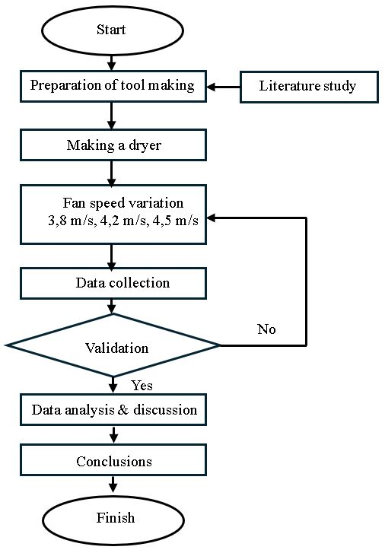

Figure 1. Research flow diagram
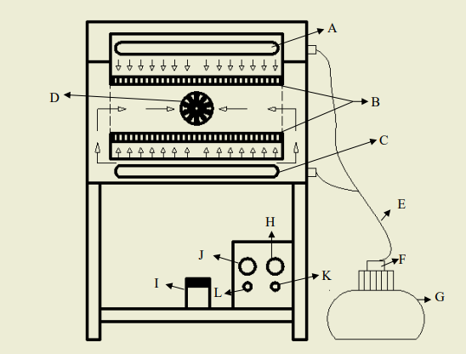

Figure 2. Components of a potato chip dryer

Description:
A. Upper burner, B, Tray J. Timer, C. Lower burner, D. Exhaust
E. Gas hose, F. Regulator, G. LPG cylinder, H. Exhaust speed regulator, I. Accu, J. Timer,
K. Indicator lamp, L. Exhaust cable connector.

- Results & Discussion
3.1. Validation
Validation was conducted first to prove that the steps taken in this study were correct and can be seen in Table 1 below,
Table 1. Validation of this research with previous research by Pilster (2015)
Time | Water mass in the present study  (%) | Water mass (Pilster, 2015)  (%)
0 min | 700 | 700
10 min | 680 | 698
20 min | 670 | 670
30 min | 640 | 650
40 min | 600 | 590
50 min | 580 | 560
60 min | 530 | 545
Average | 628,57 | 630,43

Based on Table 1 above, it can be seen that during the 60-minute research process, the potato drying process in the oven using LPG gas had an average value of 628.57 grams. While the stove using a heater by Pilster (2015) researchers had an average potato weight of 630.43 grams. The difference in research results is around 0.29%.

3.2. Relationship between time and temperature variation of flow velocity
The relationship between time and temperature can be seen in Figure 3 below based on the results of heating in the oven when drying potatoes.
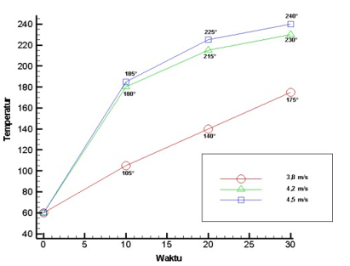

Figure 3. Relationship between time and temperature for various speeds

Figure 3 is a picture of the effect of time on temperature for different speed variations. In general, it can be seen that as time increases, the temperature also increases. Something important here is that the air flow speed of 4.5 m/s obtains a larger temperature distribution than other air speeds, namely 3.8 m/s and 4.2 m/s. This is because the magnitude of the air flow speed affects the convection heat transfer that occurs.

3.3. Potato chips capacity
Based on the calculation results, the potato chips capacity is obtained as shown
in Figure 4 below,
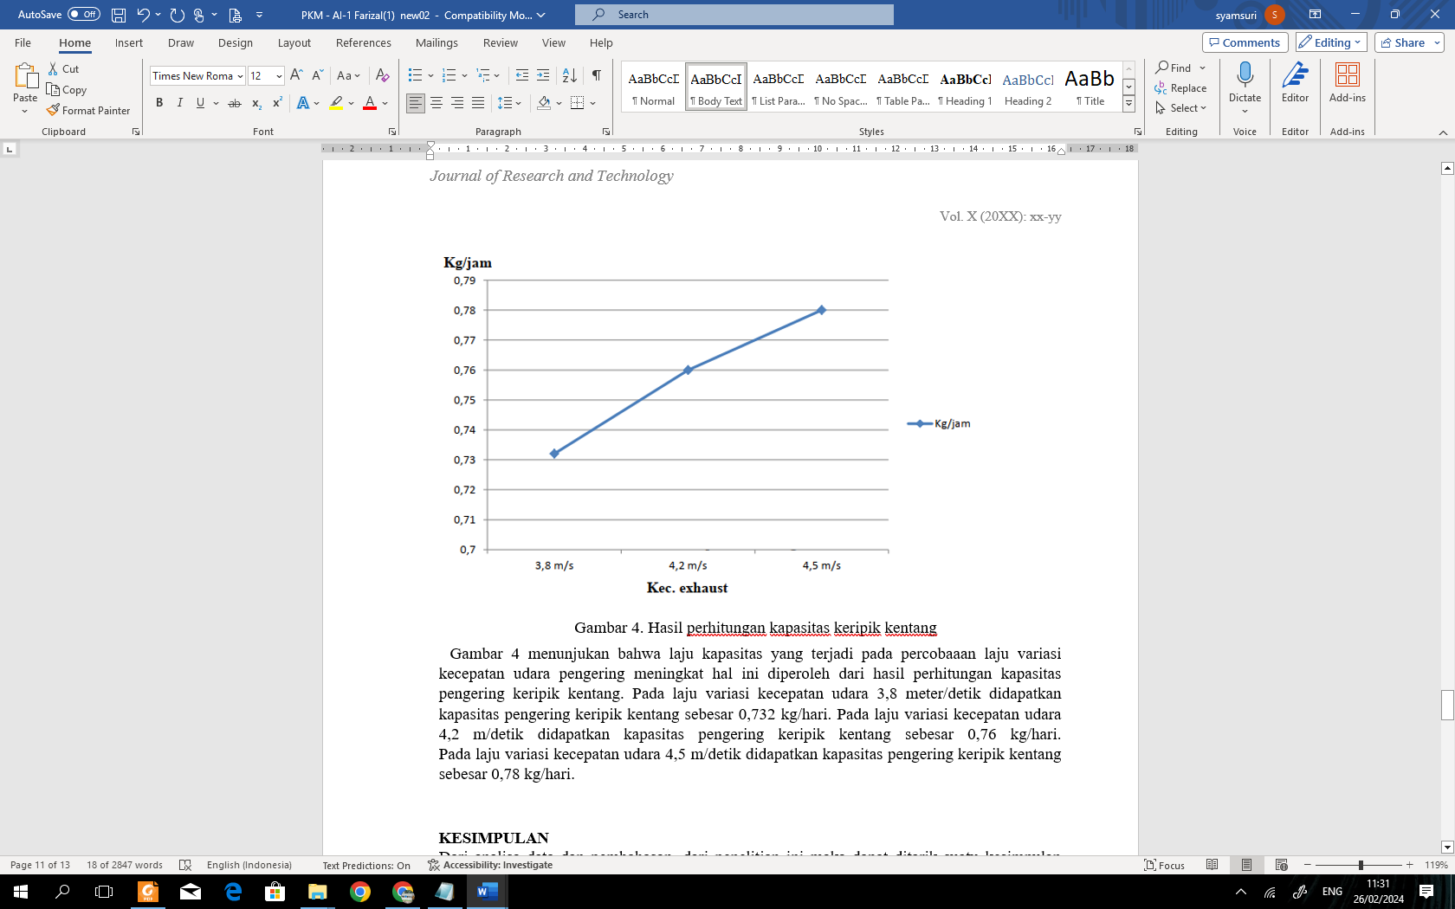

Figure 4. Calculation results for the capacity of
potato chips produced with variations in
hot fluid flow rate
Figure 4 shows that the capacity rate that occurs in the experiment of the variation rate of the drying air speed increases. This is obtained from the calculation results of the potato chip dryer capacity. At an air speed variation rate of 3.8 meters/second, the potato chip dryer capacity is 0.732 kg/day. At an air speed variation rate of 4.2 m/s, the potato chip dryer capacity is 0.76 kg/day. At an air speed variation rate of 4.5 m/s, the potato chip dryer capacity is 0.78 kg/day.

3.4. Fuel conversion during 2 weeks of
drying

Table 5. Fuel conversion

No. | Fuel | Rupiah | Explanatio
1 | LPG | Rp. 17.500 | 3kg tube
2 | Electricity | Rp. 56.000 | 1Kwh = Rp.1.444  38,7 hr
3 | Firewood | Rp. 42.000 | 1 tie/day  1 tie = Rp.3.000  (rambutan firewood )

Table 5 is the fuel conversion for use during the 2 weeks of drying crackers. From the table, it can be seen that the fuel that can be used and is economical is LPG gas fuel.

- Conclusions
From the data analysis and discussion of this study, a conclusion can be drawn, including: After testing for 30 minutes with convection calculations, it was found that an exhaust speed of 4.5 m/s can increase the heating efficiency in the oven. The greater the speed of the hot air flow in the potato chip drying chamber, the lower the weight of the chips. The use of LPG fuel is more efficient than other fuels.
Referensi
[1] Anam, M.K. 2020. Pengaruh penggunaan catalytic converter berbahan stainless steel berlapis chrome terhadap emisi gas buang sepeda motor. Skripsi. Univeritas Negeri Semarang.
[2] Budiyono. 2020. Pengaruh catalytic converter berbahan tembaga 0,6 mm berbentuk sirip terhadap hasil emisi gas buang pada honda beat tahun 2015. Jurnal Teknik Mesin UNISKA. Vol.5(2) :34-39.
[3] Chafidz, A., et. al. 2018. Application of copper-zinc metal as a catalytic converter in the motorcycle muffler to reduce the exhaust emissions. IOP Conf. Series: Earth and Environmental Science 167 (2018) 012014.
[4] Fiqhi, M.M. 2020. Pengaruh penambahan katalitik konverter kawat nikel dan tembaga berbentuk saringan terhadap emisi gas buang motor supra x 125 motor bensin. Skripsi. Universitas Negeri Semarang.
[5] Ghofur, A., et. al. 2023. Implementation peat soil adsorbent & variation of filter for reduce emission improvement from motor vehicle. Eastern-European Journal of Enterprise Technologies: Ecology 1 (10) : 27-36.
[6] Irawan, R.M.B., et. al. 2021. Effect of number of transition metal catalyst cells manganese catalytic converter on exhaust basis emission output carbon monoxide motor gasoline. SINTEK JURNAL. Vol.15(2): 118-122.
[7] Irawan, R.M.B., et. al. 2022. Unjuk kerja catalytic converter katalis tembaga-krom terhadap penurunan temperatur emisi bas buang. SINTEK JURNAL. 16(2): 131-136.
[8] Kora,A.J., et. al. 2020. In situ synthesis and preconcentration of cetylpyridinium complexed hexaiodo platinum nanoparticles from spent automobile catalytic converter leachate using cloud point extraction . Arabian Journal of Chemistry. Vol. 13: 4594–4605.
[9] Mokhtar,A., et. al. 2021. A Honeycomb-shaped brass plate catalyst to reduce motor vehicle emissions. Journal of Energy, Mechanical, Material, and Manufacturing Engineering. Vol. 6(1): 25-32.
[10] Rizza, M.A., et. al. 2023. Pengaruh komposisi katalis cu-Fe/Al₂O₃ dan panjang housing catalytic converter terhadap emisi gas buang mesin 4 langkah 125 CC. Jurnal Energi dan Teknologi Manufaktur. Vol.06(01): 13 – 20.
[11] Sendilvelan, S., et. al. 2019. Chemically heated catalytic converter design options and performance using heated metal oxides. Journal of Chemical Technology and Metallurgy. Vol.54(3) : 571-577.

Referensi buku:
[2] Strunk Jr., W. and White, E.B., 1979. The elements of style, 3rd Ed., Macmillan, New York.
Referensi bab dalam buku:
[3] Mettam, G.R. and Adams, L.B., 1999. How to prepare an electronic version of your article, in: B.S. Jones, R.Z. Smith (Eds.), Introduction to the electronic age, E-Publishing Inc., New York, 281304.
Referensi berupa paten:
[4] Clem, P.G., Rodriguez, M., Voigt, J.A., and Ashley, C.S., 2001. Process for forming epitaxial perovskite thin film layers using halide precursors. US Patent No. 6231666.
Referensi berupa laman internet:
[6] Informasi dari http://www.weld.labs. gov.cn (diakses pada hari-bulan-tahun)

